Children can be abused physically, sexually, emotionally or through neglect. The concerns that you have may make up part of a bigger picture which could help to prevent serious harm to a child. Giving families help at an early stage can prevent abuse and neglect.

This leaflet is the first of 3 levels of training for people who work in either a paid or voluntary role with children in Cornwall and the Isles of Scilly. If they have not already done so, ask your employer to talk through this leaflet with you and tell you who to contact within your organisation if you have concerns. If you think you need further training talk to the person who gave you this leaflet or to your manager.
CONTACTS

South West Child Protection Procedures www.swcpp.org.uk
Local Safeguarding Children Board Website
www.safechildren-cios.co.uk
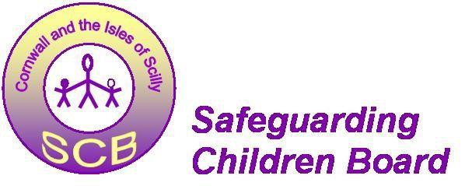

CHILD PROTECTION & SAFEGUARDING CHILDREN
in Cornwall and the Isles of Scilly
May 2015

KEEPING CHILDREN SAFE

NEVER KEEP CONCERNS
ABOUT CHILDREN’S SAFETY
TO YOURSELF

Keep this leaflet in a safe place you never know when you might need it!

No one wants to hear about children being abused, neglected or unsafe and that sometimes makes it difficult to respond so ….
Emergency Services | 999
Devon and Cornwall  Police | 101
Cornwall Children’s Social  Care Multi-Agency  Referral Unit (MARU) | 0300 1231 116
Cornwall Children’s Social  Care - out of hours | 01208 251300
Isles of Scilly Children’s  Social Care | 01720 424354
Isles of Scilly Children’s  Social Care - out of hours | 01720 422699

Remember these three important messages:

1 ALL CHILDREN HAVE A RIGHT TO BE SAFE NO MATTER WHO THEY ARE OR WHAT THEIR CIRCUMSTANCES.

2 KEEPING CHILDREN SAFE IS EVERYONE’S RESPONSIBILITY.

3 WE ALL NEED TO LISTEN TO CHILDREN EVEN THOUGH WE MAY NOT ALWAYS BE COMFORTABLE WITH WHAT WE HEAR.
WHO SHOULD I TALK TO IF I HAVE
CONCERNS ABOUT A CHILD?

Write the name and contact details here of who you should talk to in your agency if you have concerns about a child, if possible write two people down in case one is not available.

Name: ………………………………………………. Role: ………………………………………………….. Phone: …………….…………………………………. Name: …………………………………………………. Role: …………………………………………………… Phone: .……………………………………………….

If these contact people are not available do not delay but contact one of the numbers at the end of this leaflet.

REMEMBER

➢ It doesn’t matter if you are a paid worker, a volunteer or a member of the community, you have a responsibility to act if you are worried about a child.

➢ Each agency will have someone who has a responsibility for child protection and safeguarding issues
- they have had training to know
what to do next.

➢ It is not your responsibility to investigate child abuse but you should tell the appropriate person within your organisation. It will be this person’s job to decide whether to pass your concerns on. If necessary they will speak to Children’s Social Care or the police. The police and social workers can then decide whether they need to investigate your concerns.

